**1. For each environment, what was config setup(components & details).  
  
  
Dev:**Certainly! Let's focus on the specific configuration setups and components for both parts of the documentation.

Part 1: Resources Already Created and Mentioned in CFT

1. EC2 Instance

Components:

- ImageId: ami-01c83e2cc9907c1e7

- InstanceType: r6i.4xlarge

- KeyName: ec2key-linux-tableaudev-bi-noncde-dev-use1

- SecurityGroupIds: sg-02d5f524004e2fcf6/sg-0bfc83c5dd1872949

- SubnetId:

2. RDS Database

Components:

- AllocatedStorage

- DBInstanceIdentifier

- MasterUsername/MasterUserPassword

- VPCSecurityGroups

- DBSubnetGroupName

S3 Bucket

- BucketName: gbt-tableaubucket

4.. Elastic Load Balancer (ELB):

5. Log Group: tsm-dev-log   
  
6. IAM Role: GBTAWS-TableauServer_CFT  
  
Network Configuration:  
  
VPC ID: vpc-0e86f92aeebe0b3b2  
Subnet ID: subnet-09997d8d032494830  
Availability Zone: us-east-1b  
Network Interface : eni-0f10482ba64e64148

1.Tableau Command Line Interface (CLI):  
 The Tableau Command Line Interface provides various commands for managing and interacting with Tableau Server.

1. **Start/Stop/Restart Services:**
   * **tsm start**, **tsm stop**, **tsm restart**: Manages the lifecycle of Tableau Server services.
2. **Activate/Deactivate Licenses:**
   * **tsm licenses activate** and **tsm licenses deactivate**: Manages Tableau Server licenses.
3. **Backup and Restore:**
   * **tsm maintenance backup** and **tsm maintenance restore**: Creates backups and restores Tableau Server data.
4. **User Management:**
   * **tsm user**: Manages users and groups on Tableau Server.
5. **Server Configuration:**
   * **tsm configuration set**: Configures various Tableau Server settings.
6. **SSL Configuration:**
   * **tsm ssl**: Manages SSL configurations for Tableau Server.
7. **Content Migration:**
   * **tsm data-access export** and **tsm data-access import**: Exports and imports data source connections and settings.

2.Common Troubleshooting Steps:

1. **Check Logs:**
   * Log files are crucial for understanding what's happening behind the scenes. Key log files include **tabadmin.log**, **vizportal.log**, and **wgserver.log**. Analyzing these logs can provide insights into errors or issues.
2. **Service Status:**
   * Confirming that all Tableau Server services are running is essential. Commands like **tabadmin status** or **tsm status -v** can be used to check the status of services.
3. **Configuration Settings:**
   * Ensuring that your Tableau Server is configured correctly is vital. Use commands like **tsm configuration get** to view current configurations and **tsm configuration set** to modify them.
4. **Permissions:**
   * Permissions issues can cause various problems. Check and adjust permissions using command-line tools like **tabcmd** or **tsm**.
5. **Database Connections:**
   * Problems with database connections can lead to data source issues. Verify database connections using commands like **tsm data-access status** or **tsm data-access set**.
6. **Network Configuration:**
   * Ensure that there are no network issues impacting communication between Tableau Server components. Tools like **ping** or **telnet** can be useful for network troubleshooting.
7. **Restart Services:**
   * Restarting services can be a quick way to resolve certain issues. Use commands like **tabadmin restart** or **tsm restart** for service restarts.
8. **Upgrade/Update:**
   * Staying up-to-date with the latest Tableau Server version is essential. Commands like **tsm pending-changes apply** can be used during the upgrade process.

3.Tableau Server logs and log file locations:

**1. Log File Locations:**

The default log file locations on a Tableau Server installation can be found in the following directories:

* **Linux:**
  + **/var/opt/tableau/tableau_server/data/tabsvc/logs** for primary logs.
  + **/var/opt/tableau/tableau_server/data/tabsvc/vizqlserver/Logs** for VizQL logs.

**2. Checking Logs:**

* You can use a text editor or command-line tools to view the content of log files. On the command line, you can use tools like **cat**, **tail**, or **more** to view logs.

**Example (Linux):**

**cat /var/opt/tableau/tableau_server/data/tabsvc/logs/*.log**

**3. Tableau Server Log Types:**

* Some of the key log files include:
  + **tabadmin.log**: Records administrative tasks and configuration changes.
  + **wgserver.log**: Contains information about server processes and activities.
  + **vizqlserver.log**: Captures information related to VizQL processes.
  + **backgrounder.log**: Logs background job activity.
  + **dataengine.log**: Records information about data engine processes.

**4. Filtering Logs:**

* Logs can be extensive, so filtering by date or specific keywords can be useful.

**Example (Linux):**

**cat /var/opt/tableau/tableau_server/data/tabsvc/logs/*.log | grep "error"**

**Tableau Server Administration Details:  
  
1. Installation and Configuration:** Any guides or links related to the installation process and configuration best practices for Tableau Server.  
  
There are loads of different pages to read through for this but I would start [here](https://urldefense.com/v3/__https:/help.tableau.com/current/server-linux/en-us/requ.htm__;!!KLL8VBKIGhc0BcQ38Y9qmONVtVtEUw!2UjXIuHQ1Ih5eVXqBDkruxyfxKAA-xLLhLs1zABuR5CJLSYBlIkzPEaGKQbTBDcRk_CHTvNzsvf1PGcqSeXUGILU2n4ENPKMxg947h0fZEA$) and then for the actual install process you can see [here](https://urldefense.com/v3/__https:/help.tableau.com/current/server-linux/en-us/setup.htm__;!!KLL8VBKIGhc0BcQ38Y9qmONVtVtEUw!2UjXIuHQ1Ih5eVXqBDkruxyfxKAA-xLLhLs1zABuR5CJLSYBlIkzPEaGKQbTBDcRk_CHTvNzsvf1PGcqSeXUGILU2n4ENPKMxg94c6fEBOo$)  
https://help.tableau.com/current/server-linux/en-us/requ.htm  
https://help.tableau.com/current/server-linux/en-us/setup.htm  
  
**2**. **User and Permission Management**: Resources detailing user management, permission assignment, and best practices for controlling access within Tableau server  
  
[Here](https://urldefense.com/v3/__https:/help.tableau.com/current/server-linux/en-us/manage_site.htm__;!!KLL8VBKIGhc0BcQ38Y9qmONVtVtEUw!2UjXIuHQ1Ih5eVXqBDkruxyfxKAA-xLLhLs1zABuR5CJLSYBlIkzPEaGKQbTBDcRk_CHTvNzsvf1PGcqSeXUGILU2n4ENPKMxg94dup2YZQ$) for general how-to information and [here](https://urldefense.com/v3/__https:/help.tableau.com/current/blueprint/en-us/bp_governance_in_tableau.htm__;!!KLL8VBKIGhc0BcQ38Y9qmONVtVtEUw!2UjXIuHQ1Ih5eVXqBDkruxyfxKAA-xLLhLs1zABuR5CJLSYBlIkzPEaGKQbTBDcRk_CHTvNzsvf1PGcqSeXUGILU2n4ENPKMxg94l0VsCl8$) for best practices on governance in general (which takes users/groups into consideration   
<https://help.tableau.com/current/server-linux/en-us/manage_site.htm>  
https://help.tableau.com/current/blueprint/en-us/bp_governance_in_tableau.htm  
  
**3**. **Monitoring and Maintenance**: Any Documentation or recommended resource for monitoring server performance, system health check, and maintenance routines.  
  
Utilise AWS CloudWatch Metrics, Alarms and Logs for this (docs [here](https://urldefense.com/v3/__https:/docs.aws.amazon.com/AmazonCloudWatch/latest/monitoring/WhatIsCloudWatch.html__;!!KLL8VBKIGhc0BcQ38Y9qmONVtVtEUw!2UjXIuHQ1Ih5eVXqBDkruxyfxKAA-xLLhLs1zABuR5CJLSYBlIkzPEaGKQbTBDcRk_CHTvNzsvf1PGcqSeXUGILU2n4ENPKMxg94qnS9XiE$))  
https://docs.aws.amazon.com/AmazonCloudWatch/latest/monitoring/WhatIsCloudWatch.html  
  
**4**. **Backup And Recovery Procedures**: Guides or Documentation outlining backup strategies and recovery procedures specific to tableau server.  
  
How to take Tableau backups is described [here](https://urldefense.com/v3/__https:/help.tableau.com/current/server/en-us/backup_restore.htm__;!!KLL8VBKIGhc0BcQ38Y9qmONVtVtEUw!2UjXIuHQ1Ih5eVXqBDkruxyfxKAA-xLLhLs1zABuR5CJLSYBlIkzPEaGKQbTBDcRk_CHTvNzsvf1PGcqSeXUGILU2n4ENPKMxg94QQnmK_k$). Don’t take instance snapshots only, make sure you automate Tableau backup creation (some scripts from a TIL colleague for that can be found [here](https://urldefense.com/v3/__https:/www.theinformationlab.co.uk/community/blog/tableau-server-housekeeping-made-easy-linux-edition/__;!!KLL8VBKIGhc0BcQ38Y9qmONVtVtEUw!2UjXIuHQ1Ih5eVXqBDkruxyfxKAA-xLLhLs1zABuR5CJLSYBlIkzPEaGKQbTBDcRk_CHTvNzsvf1PGcqSeXUGILU2n4ENPKMxg94swGR72I$))   
<https://help.tableau.com/current/server/en-us/backup_restore.htm>  
https://www.theinformationlab.co.uk/community/blog/tableau-server-housekeeping-made-easy-linux-edition/  
  
**5. Security best practices**: Any recommended links or documentation for implementing security best practices, including SSL configuration, firwall setting,  
  and security updates.  
  
The Tableau security hardening checklist can be found [here](https://urldefense.com/v3/__https:/help.tableau.com/current/server-linux/en-us/security_harden.htm__;!!KLL8VBKIGhc0BcQ38Y9qmONVtVtEUw!2UjXIuHQ1Ih5eVXqBDkruxyfxKAA-xLLhLs1zABuR5CJLSYBlIkzPEaGKQbTBDcRk_CHTvNzsvf1PGcqSeXUGILU2n4ENPKMxg94o1kW2RE$)  
https://help.tableau.com/current/server-linux/en-us/security_harden.htm  
  
**6. Version Upgrades and patching:** Links or resource detailing the process for version upgrades, patching, and staying updated with the latest tableau server release  
  
Docs on performing a blue / green upgrade for Tableau are [here](https://urldefense.com/v3/__https:/help.tableau.com/current/server/en-us/server-upgrade-blue-green.htm__;!!KLL8VBKIGhc0BcQ38Y9qmONVtVtEUw!2UjXIuHQ1Ih5eVXqBDkruxyfxKAA-xLLhLs1zABuR5CJLSYBlIkzPEaGKQbTBDcRk_CHTvNzsvf1PGcqSeXUGILU2n4ENPKMxg94T5tHjW0$)  
https://help.tableau.com/current/server/en-us/server-upgrade-blue-green.htm  
  
**7. Content Management Guidelines**: Resources or Guides for effective content management, organization, and maintenance within Tableau server.  
  
See the same governance page that I linked earlier ([here](https://urldefense.com/v3/__https:/help.tableau.com/current/blueprint/en-us/bp_governance_in_tableau.htm__;!!KLL8VBKIGhc0BcQ38Y9qmONVtVtEUw!2UjXIuHQ1Ih5eVXqBDkruxyfxKAA-xLLhLs1zABuR5CJLSYBlIkzPEaGKQbTBDcRk_CHTvNzsvf1PGcqSeXUGILU2n4ENPKMxg94l0VsCl8$))  
https://help.tableau.com/current/blueprint/en-us/bp_governance_in_tableau.htm  
  
**8. Performance Optimization Strategies:** Any recommended links or documentation to optimize server performance, including query performance tuning and resource allocation.  
  
Start with the page [here](https://urldefense.com/v3/__https:/help.tableau.com/current/pro/desktop/en-us/performance_tips.htm__;!!KLL8VBKIGhc0BcQ38Y9qmONVtVtEUw!2UjXIuHQ1Ih5eVXqBDkruxyfxKAA-xLLhLs1zABuR5CJLSYBlIkzPEaGKQbTBDcRk_CHTvNzsvf1PGcqSeXUGILU2n4ENPKMxg94voW9UEg$) but note the whitepapers linked in the learn more section on that page. It focuses on workbook performance because you will get more gains improving that than trying to tweak the server. There is a section of the docs that starts [here](https://urldefense.com/v3/__https:/help.tableau.com/current/server-linux/en-us/perf_toc.htm__;!!KLL8VBKIGhc0BcQ38Y9qmONVtVtEUw!2UjXIuHQ1Ih5eVXqBDkruxyfxKAA-xLLhLs1zABuR5CJLSYBlIkzPEaGKQbTBDcRk_CHTvNzsvf1PGcqSeXUGILU2n4ENPKMxg94ymDE3LM$) related specifically to server performance   
  
<https://help.tableau.com/current/pro/desktop/en-us/performance_tips.htm>  
https://help.tableau.com/current/server-linux/en-us/perf_toc.htm  
  
  
**10. Capacity Planning Recommendations**: Resources or Guides for capacity planning, resource Usage analysis, and scalability planning within tableau server.  
  
The repository will have the information you are looking for with regard to this (see [here](https://urldefense.com/v3/__https:/help.tableau.com/current/server-linux/en-us/perf_collect_server_repo.htm__;!!KLL8VBKIGhc0BcQ38Y9qmONVtVtEUw!2UjXIuHQ1Ih5eVXqBDkruxyfxKAA-xLLhLs1zABuR5CJLSYBlIkzPEaGKQbTBDcRk_CHTvNzsvf1PGcqSeXUGILU2n4ENPKMxg946Y0sH7c$)). I would suggest you start with the workbooks [here](https://urldefense.com/v3/__https:/github.com/tableau/community-tableau-server-insights__;!!KLL8VBKIGhc0BcQ38Y9qmONVtVtEUw!2UjXIuHQ1Ih5eVXqBDkruxyfxKAA-xLLhLs1zABuR5CJLSYBlIkzPEaGKQbTBDcRk_CHTvNzsvf1PGcqSeXUGILU2n4ENPKMxg94L3eoOQc$) if you want to start analysing the data.  
**<https://help.tableau.com/current/server-linux/en-us/perf_collect_server_repo.htm>  
  
https://github.com/tableau/community-tableau-server-insights**

**Steps to Optimized Tableau Volume:**URL: https://tableaulove.com/elastic-ebs-volumes-hell-wheels-tableau-server-cloud/ **Volume Optimization Steps:**1. Stop Application first from 1st nodes:

tsm stop

2. Check Application Status:

tsm status

3. Stop EC2 instance.

4. Select volume -> click modify volume -> change volume size -> modify

5. Start EC2 instance

6. Start the application

tsm start

7. Check status

tsm status

**Tableau Post Upgradation Task**   
  
Step1: Server setup and Accessibility  
  
Once the server is set up and reachable via localhost, follow the steps below to ensure the website is up and running.  
  
1.1 SSL Certificate Creation   
  
-Ensure an SSL certificate is created and imported into the AWS Certificate Manager of the AWS Account where you plan to provision the server.  
  
-Ticket Request:  
-Ticket Name : Venafi - New Certificate Request  
- Ref Ticket: #SR-1261940  
- Contact Team Mail ID : GBTCertificateAdmin@amexgbt.com  
  
  
1.2 Import SSL Certificate  
  
-Create a ticket for the S3 bucket , as there is on specific ticket request to import SSL certificates  
  
-Ticket Name : AWS S3 Bucket  
-Ref Ticket: #SR-1297714  
-Contact Team Mail id : GBTCloud-ITOps@amexgbt.com  
  
Step 2: Certificate Mapping with Load Balancer  
  
- If the created certificates are not mapped with the tableau load balancer , raise the following ticket request:  
  
-Map domain with load Balancer  
-Ticket Name : DNS Record - Create/Modify/Delete  
-Ref Ticket: #SR-#1294989  
-Contact Team Mail id : GBTNetwork-ITOps@amexgbt.com  
  
Step 3: URL Allowance in GBT Network:

-After the above configuration, its essential to allow the URL in the GBT Network. Raise a request to the firewall team for URL allowance.  
  
-Allow URL in GBT Network   
-Ticket Name: Egencia Palo Alto Firewall  
-Ref Ticket: #1293486  
-Contact Team Mail id : CyberNetOps@amexgbt.com  
  
  
  
  
Step 4 : Instance Attachment to target Group  
-Ensure that the instances are attached to the target group.

Step 5: URL Check and SSL Certificate Issues   
  
-After all configuration are completed, access the URL . if there are issues , especially if the website is not secure with an HTTPS error, check with the team that created the SSL certificate.  
-Possible Action :  
-Create a ticket to import SSL certificate into the AWS Certificate Manager ( as mentioned in Step1).

**Tableau Error and Resolutions:**  
1. Tableau Server Error: "No suitable driver installed or the URL is incorrect"  
  
During our analysis on Tableau Server, we encountered an issue when attempting to open any dashboard under the Server Status -> Analysis section. The error message received was: "No suitable driver installed or the URL is incorrect."  
   
 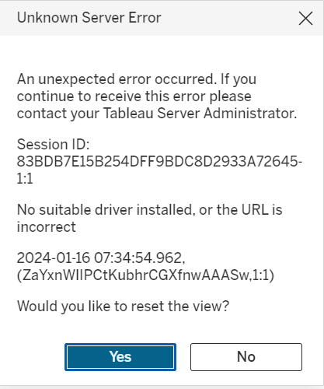  
  
  
  
Resolution Steps:  
  
1. Visit the official Tableau driver website to identify the latest available driver <https://www.tableau.com/support/drivers>  
  
2. On the driver page, select the following parameters:  
 - Select Data Source: Postgress Sql   
 - OS: Linux  
  
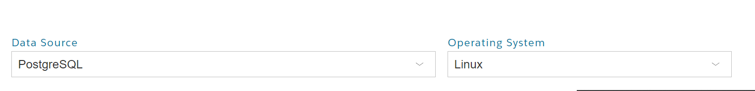  
  
  
3. Download the latest driver from the provided URL: <https://jdbc.postgresql.org/download/>  
  
4. Save the downloaded driver file locally.  
  
 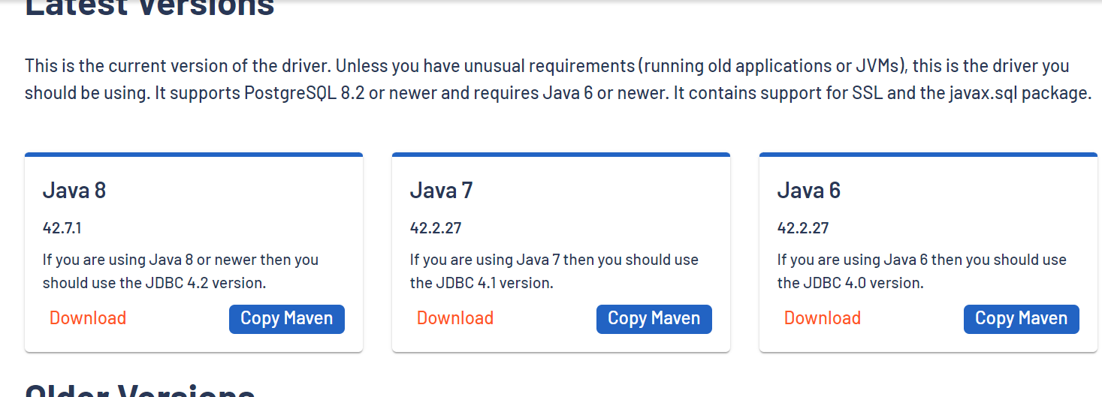

5. Upload the driver file to the S3 bucket associated with the application.  
  
6. Retrieve the JDBC driver path from the official website:  
 Path: /opt/tableau/tableau_driver/jdbc  
  
7. Log in to the Tableau Server and navigate to the specified path:  
 cd /opt/tableau/tableau_driver/jdbc  
  
8. Replace the existing driver file with the newly downloaded file.  
  
9. Adjust the permissions of the driver file:  
 chmod 644 /opt/tableau/tableau_driver/postgresql-42.7.1.jar  
  
10. Restart the Tableau Server  
 tsm restart   
  
11. After a successful server restart, verify from the UI side to confirm that the issue has been resolved.  
  
 